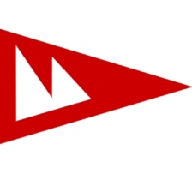
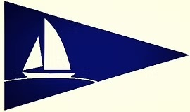
Magothy Mayhem Pursuit Race

Saturday, September 19

ORGANIZING AUTHORITIES

Potapskut Sailing Association and Magothy River Sailing Association

SAILING INSTRUCTIONS
1 RULES
1.1 This is just a game and is supposed to be fun
1.2 The regatta will be governed by the rules as defined in The Racing Rules of Sailing (RRS) for 2025-2028, Including the US Prescriptions.
1.3 If you had a valid PHRF of the Chesapeake certificate that’s great if you don’t a handicap rating for this race only will be provided for you but, if you don’t like it, see 1.1.
1.4 Boats racing in the Non-Spinnaker and Cruising / Novice (no spinnakers) class shall hoist only one headsail at a time, except during sail changes.
2 COMMUNICATIONS WITH COMPETITORS
2.1 Notices to competitors will be published on https://nextsailor.com/regatta/1370 (NextSailor Race Website) and may also be communicated to skippers via e-mail.
2.2 The Race Committee may, at its option, use VHF channel 72 to communicate with competitors.
3 CHANGES TO THE SAILING INSTRUCTIONS
Any change to the sailing instructions will be posted on the NextSailor Notice board https://nextsailor.com/regatta/1370 before 1200 ET on the day before (Friday) the race (Saturday).
4 COURSES
4.1 RC shall designate one (1) of three (3) possible courses to be sailed (see Attachment “A”).
4.2 The designated course will be displayed on the RC Boat. The RC Boat will also
attempt to announce the course designation on VHF channel 72 before the start sequence.
5. MARKS
5.1 The marks of the course are as follows:
5.1.1 Fixed yellow race Magothy marks as identified in Attachment “B”,
5.1.2 Mark L - Baltimore Light (39° 03.55’ N, 076° 23.94 ’W), and
5.1.3 Mark K - Craighill Channel Mark G “1C” (39° 01.38’ N, 076° 22.68’ W), Northeast of Sandy Point Light
5.2 The Magothy River entrance channel marks (R “2”, R”4”, G “3”, and G”5”) must be honored on the channel side.
5.3 Dobbin Island Day Mark G “1” must also be honored on the correct side (Or you will find out why in a hurry).
6. THE START
6.1 The starting line shall be between a staff displaying a code flag “Q” (yellow flag) on the RC boat and Magothy Racing Mark “A”.
6.2 This shall be a pursuit race with a reverse PHRF Time over Distance (ToD) starting order. The boat with the slowest rating (highest PHRF number) shall start first and the fastest rating (lowest PHRF number) shall start last.
6.3 The starting times for each boat and course will be posted on the NextSailor Race Website and emailed to registered skippers.
6.3 Rendezvous time at Magothy Racing Mark “A” is 12:30
6.4 The RC shall signal the starting sequence as follows. This changes RRS 26.
13:00 Warning (code flag “F”) with a sound
13:01 Preparatory for the first boat to start (code flag “P”) with a sound
13:04 Lower code flag “P” with a sound
13:05 Starting signal for the first boat to start - lower code flag “F” with 1 sound
Each Subsequent Starting signal for remaining boats - briefly raise code flag “F” with 1 sound
6.5 A boat's individual preparatory signal is four (4) minutes prior to her individual scheduled start. After the first boat has started, there will be no visual signal or sound for any subsequent preparatory signal. This changes RRS 26.
6.6 The race shall use GPS time for starting. The RC will attempt to broadcast a five (5) second countdown for each starting time on VHF channel 72. Failure of the RC to announce a start time will not be grounds for redress. This changes RRS 61.4(b).
6.7 After the Warning signal for the first start, boats shall stay clear of the starting area until four (4) minutes before their scheduled starting time.
6.8. An OCS boat shall be signaled by the Race Committee by briefly displaying code flag “X” with one (1) sound.
6.9 In the event of an OCS, the Race Committee may attempt to verbally notify the OCS starter via VHF channel 72. The Race Committee’s failure to verbally notify an OCS starter will not be grounds for redress.
6.10 A boat that is OCS shall continue sailing to the first mark and shall not sail back to restart but will be considered as starting properly. She will receive a 10-minute scoring penalty if she is within two minutes of her starting time. If the boat starts greater than two minutes early, they will be scored as DNS (Don’t try to game the system). This changes RRS rules 28.1 and 44.3(c).
6.11 In the event a postponement is signaled on the water, RC shall announce the revised start times on VHF channel 72 before lowering code flag “AP”.
7. CHANGE OF COURSE AFTER THE START
A change of course after the start will be limited to “shorten course”. It shall be signaled from the Race Committee boat by displaying code flag “S” with two sound signals.
8. THE FINISH
The finish line shall be between code flag “Q” (yellow flag) on the Race Committee boat and the adjacent fixed racing mark of the course.
9. TIME LIMITS
9.1 The time limit for the race is 1630 ET hours
9.2 If a boat has sailed the course within the race time limit it will be scored in the order of their finish. Boats not finished by 1630 ET will be scored Time Limit Expired (TLE).
10. PROTESTS
10.1 This is a fun race, and we are expecting that boats take penalty turns if they are in doubt whether they fouled another boat.
10.2 If your protest isn’t resolved on the water by penalty turns a written protest (including protester, protestee, and a description of the incident) shall be submitted within 60 minutes of the boat’s finishing time by either delivering to the Race Committee at the PSA clubhouse or emailed to magothymayhem@magothysailing.com.
10.3 Protests will be heard at the place and time specified by the Principal Race Organizer.
11. SCORING
11.1 Boats will be scored in the order of their finish
11.2 In the case of a shortened race, it will be re-scored using your PHRF handicap, race distance and elapsed time.
12 AWARDS
12.1 Awards for first place will be awarded with at least three (3) boats entered for a class. Second place will be awarded with at least five (5) boats entered; third place with six (6) to ten (10) boats entered, fourth place with 11 to 14 boats entered, and fifth place with 15 or more boats entered (yes, we are being optimistic for 15 or more boats in a class…)
12.2 Additional awards may be given at the discretion of the organizing authority
13 DISCLAIMER OF LIABILITY
Competitors participate in the regatta entirely at their own risk. See RRS Rule 4, Decision to Race. The organizing authority will not accept any liability for material damage or personal injury, or death sustained in conjunction with or prior to, during, or after the regatta.

Attachment A
Course A

Start @ Magothy Mark A
Magothy Mark “G” (Port)
Magothy Mark “C” (Starboard)
Magothy Mark “E” (Starboard)
Finish @ Magothy Mark “A”
Distance ~5.1 nm

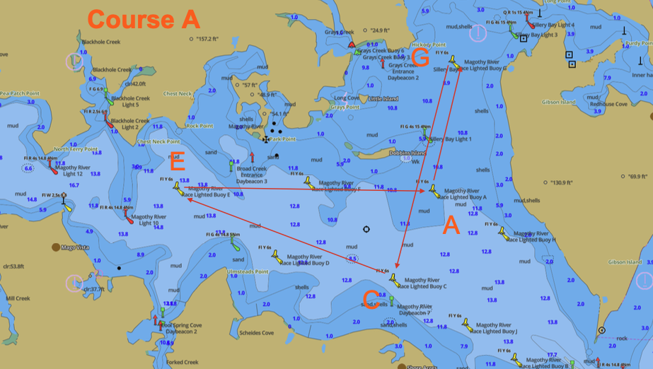

Attachment A
Course B

Start @ Magothy Mark A
Magothy Mark “B” (Port)
Baltimore Light, Mark “L” (Either Direction)
Magothy Mark “B” (Starboard)
Finish @ Magothy Mark “A”
Distance ~6.4 nm

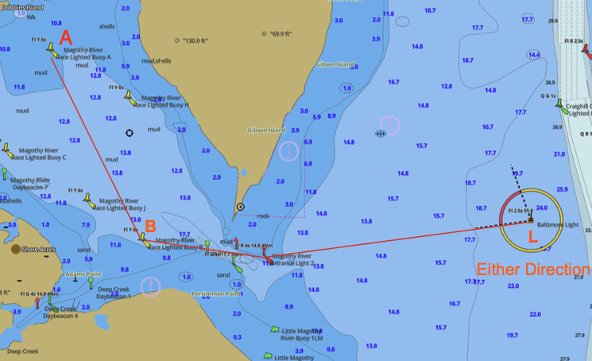

Attachment A
Course C

Start @ Magothy Mark “A”
Magothy Mark “B” (Port)
Baltimore Light, Mark “L” (Starboard)
Craighill Channel G “1C” Mark “K” (Starboard)
Magothy Mark “B” (Starboard)
Finish @ Magothy Mark “A”
Distance ~10.6 nm

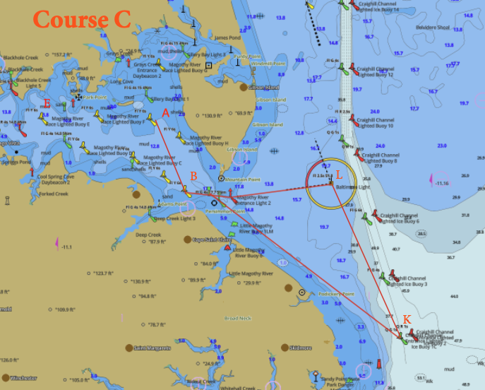
Attachment B
Magothy Racing Mark Locations
